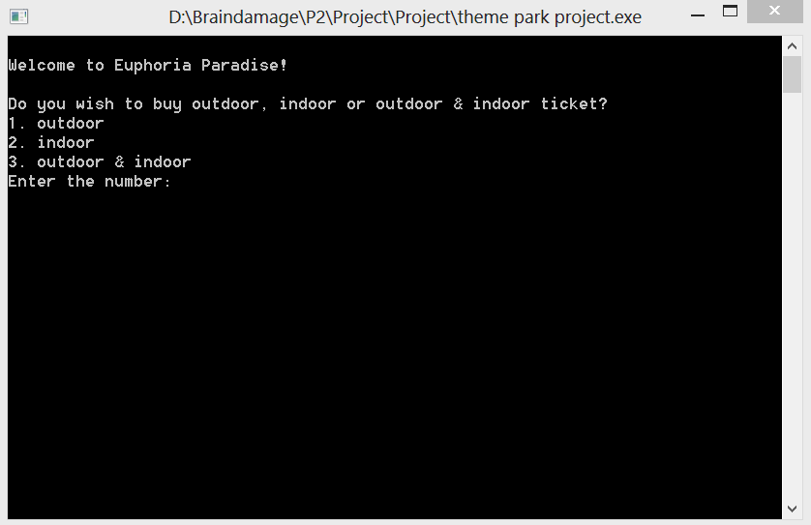

This is our main page, user will be prompted to enter 1, 2 or 3 to choose their desire ticket.

Every ticket will have a different price. But it all leads to the same page. Let’s say I key in 3 as my desire ticket.

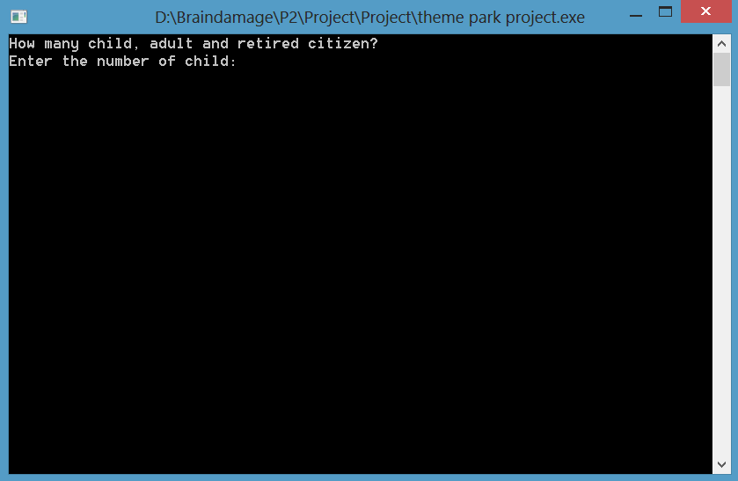

This page will came out, and user are prompt to enter the numbers of child, adult and retired citizen. Now the difference is if I were to key in 2 child and 2 adults, or I only key in 2 adults a family package and a couple package will be taken into calculation. Other than that, a standard Alacarte package will be introduce. I will key in 2 child and 2 adults.

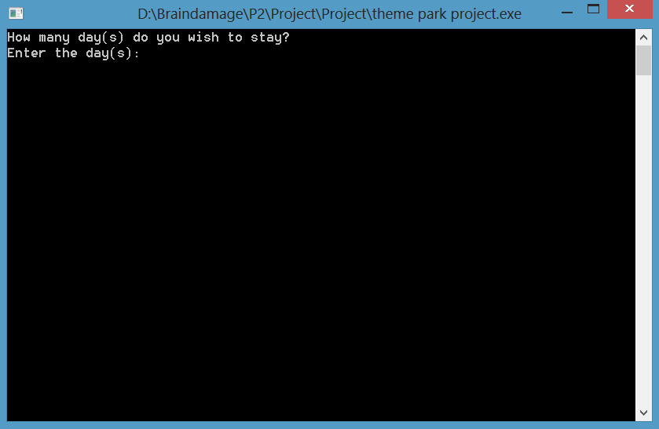

The user will be prompt to enter how many days to wish to play at the theme park. I will key in 3 as an example.

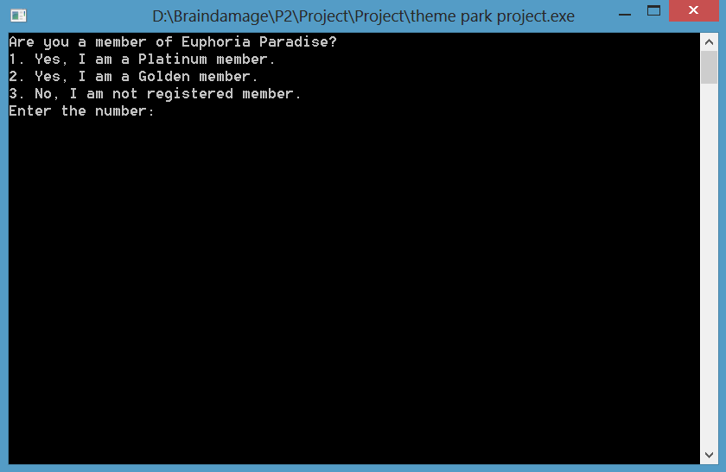

In this section user will be prompt to key in their membership. If key in 1 or 2:

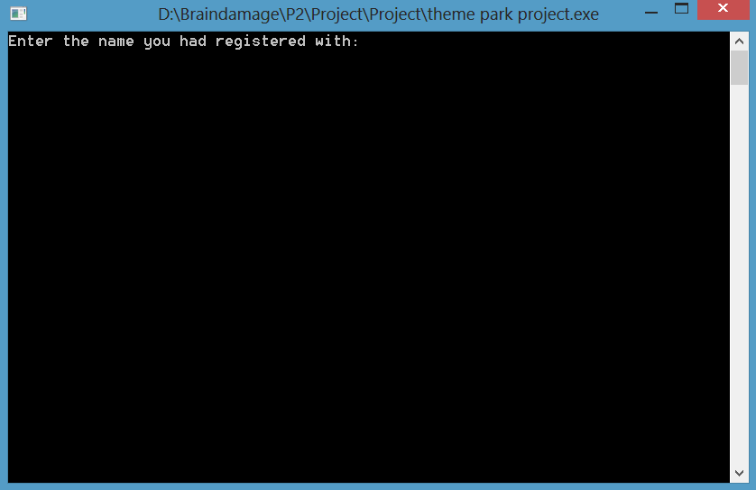

User will be asked to key in the name they had registered with. If the name is in the registration the discount will be given. If the name is not in the registration, there will be no discount.

Name is in registration:

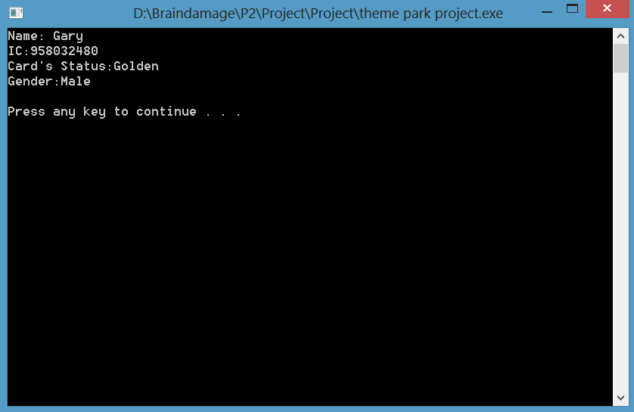

Name is not in the registration:

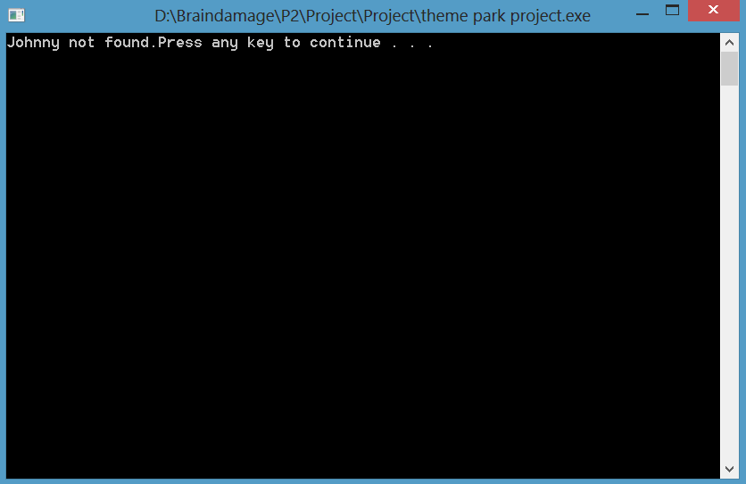

But what if the user don’t have a membership?

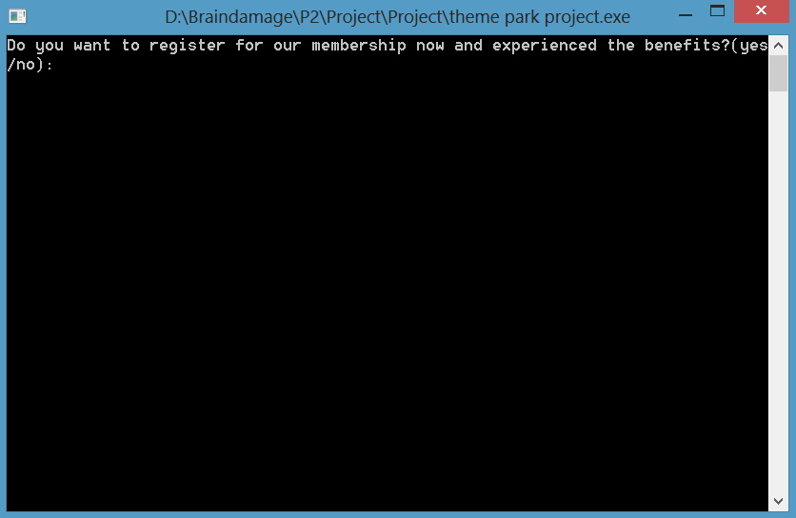

Then they will be ask if they are interested in registering one. If no, the program will proceed to payment calculation. If yes: User will be ask for their name, IC, gender and membership.

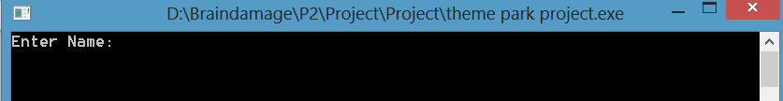

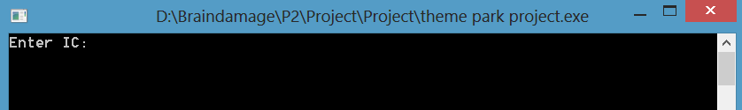

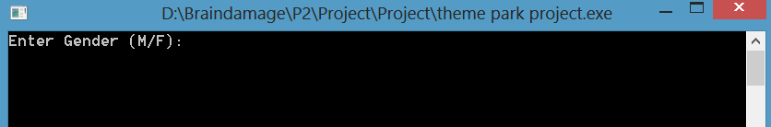

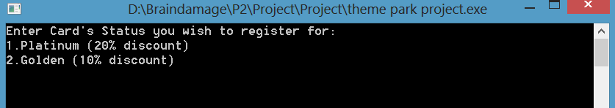

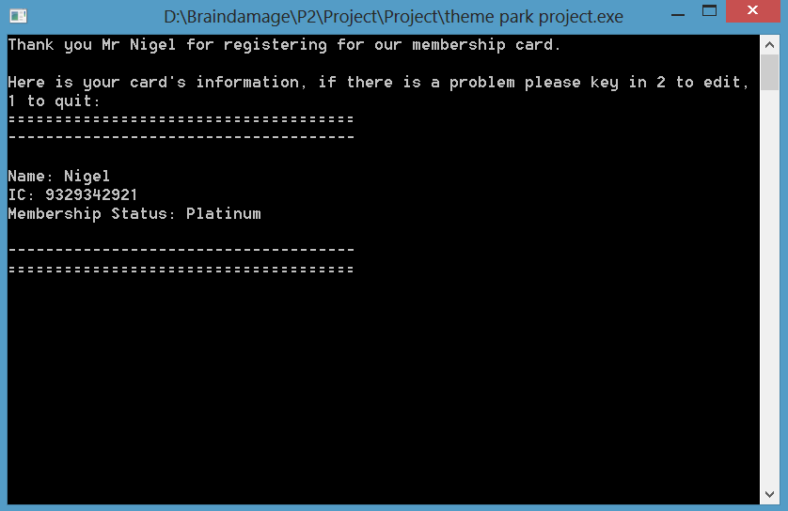

If the user key in the wrong information. They can press 2 to edit or 1 to continue.

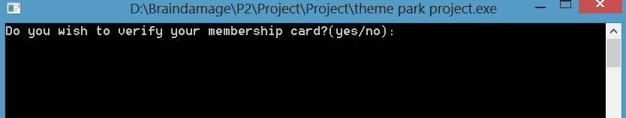

User are given the choice to verify if their membership has been successfully register. If yes, program will show their registration information. If no , program will proceed to calculations.

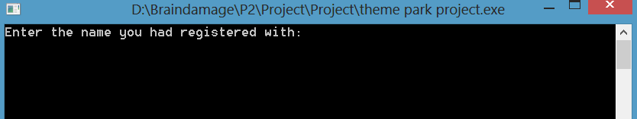

After key in their registration name, program will show the informations.

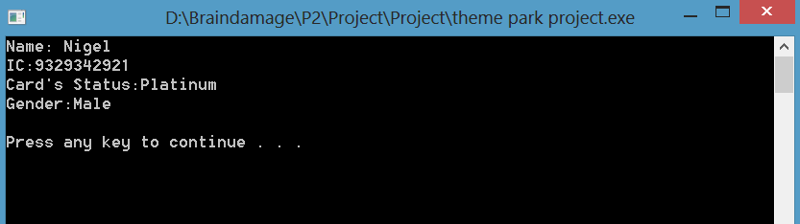

After pressing enter:

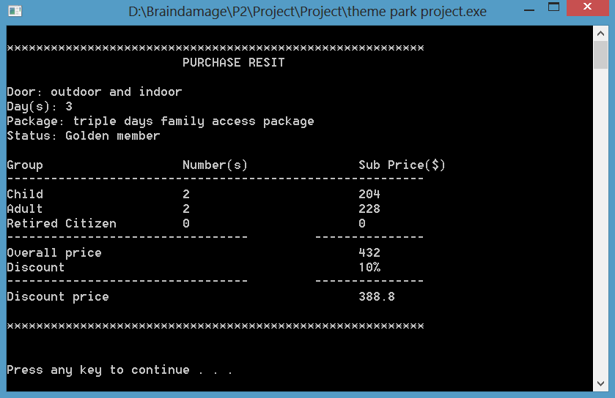

The Overall price had been calculated, theme park ticket status is stated at Door. Days and card Status are also stated. Package is shown to the users. And all the calculation are shown too.

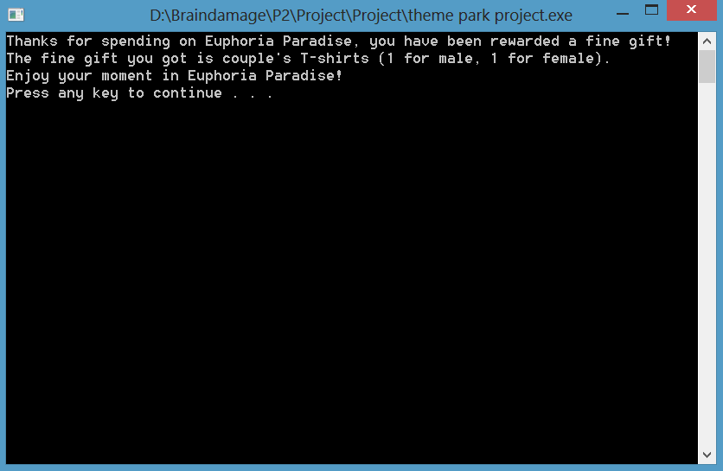

At the end of the program, user are given a random gift based on their spendings. The more they spend the better the gift is. Like in this case the gift is a couple’s T-shirts.

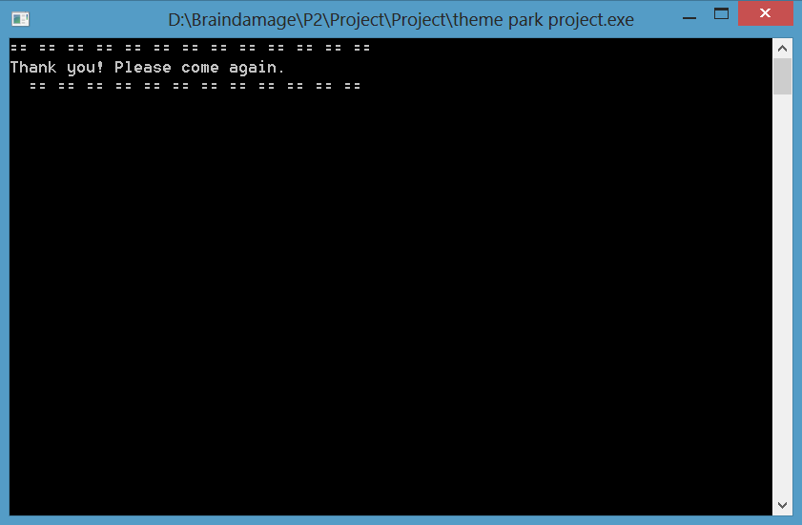

A thank you note.